RPL13A (P40429)
>sp|P40429|RL13A_HUMAN Large ribosomal subunit protein uL13 OS=Homo sapiens OX=9606 GN=RPL13A PE=1 SV=2
MAEVQVLVLDGRGHLLGRLAAIVAKQVLLGRKVVVVRCEGINISGNFYRNKLKYLAFLRK
RMNTNPSRGPYHFRAPSRIFWRTVRGMLPHKTKRGQAALDRLKVFDGIPPPYDKKKRMVV
PAALKVVRLKPTRKFAYLGRLAHEVGWKYQAVTATLEEKRKEKAKIHYRKKKQLMRLRKQ
AEKNVEKKIDKYTEVLKTHGLLV
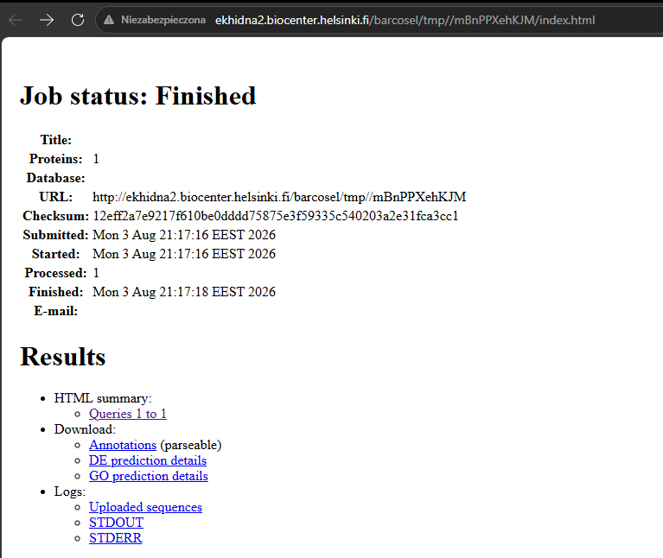
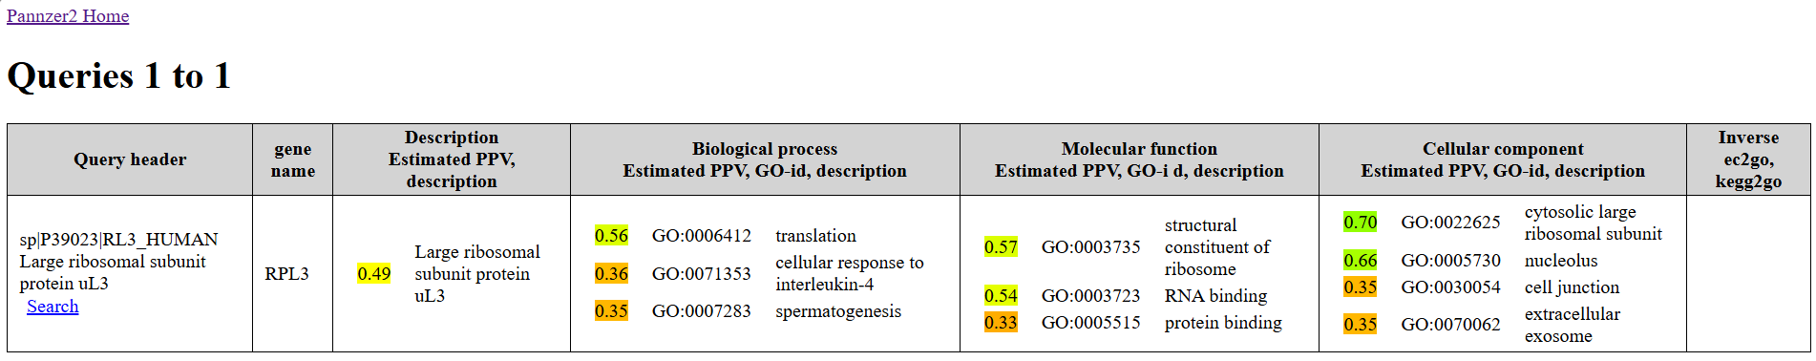
ekhidna2.biocenter.helsinki.fi/barcosel/tmp//mBnPPXehKJM/PANZ_1.html

1) RPL13A (P40429)
(wyniki z linku: mBnPPXehKJM/PANZ_1.html)
Biological process
- translation
- ribosome assembly
- RNA metabolic process
Molecular function
- structural constituent of ribosome
- RNA binding
Cellular component
- cytosolic large ribosomal subunit
- nucleolus
- ribosome

https://services.healthtech.dtu.dk/cgi-bin/webface2.cgi?jobid=6A70E37C003135CD5F925483&wait=20
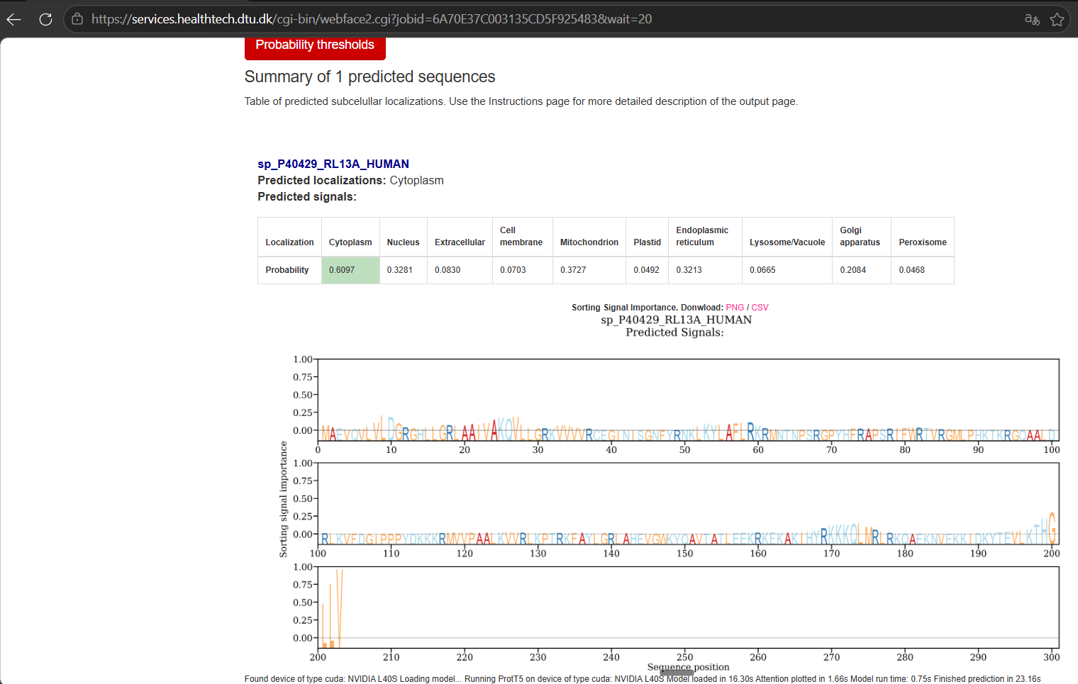

RPS6 (P62753)
>sp|P62753|RS6_HUMAN Small ribosomal subunit protein eS6 OS=Homo sapiens OX=9606 GN=RPS6 PE=1 SV=1
MKLNISFPATGCQKLIEVDDERKLRTFYEKRMATEVAADALGEEWKGYVVRISGGNDKQG
FPMKQGVLTHGRVRLLLSKGHSCYRPRRTGERKRKSVRGCIVDANLSVLNLVIVKKGEKD
IPGLTDTTVPRRLGPKRASRIRKLFNLSKEDDVRQYVVRKPLNKEGKKPRTKAPKIQRLV
TPRVLQHKRRRIALKKQRTKKNKEEAAEYAKLLAKRMKEAKEKRQEQIAKRRRLSSLRAS
TSKSESSQK
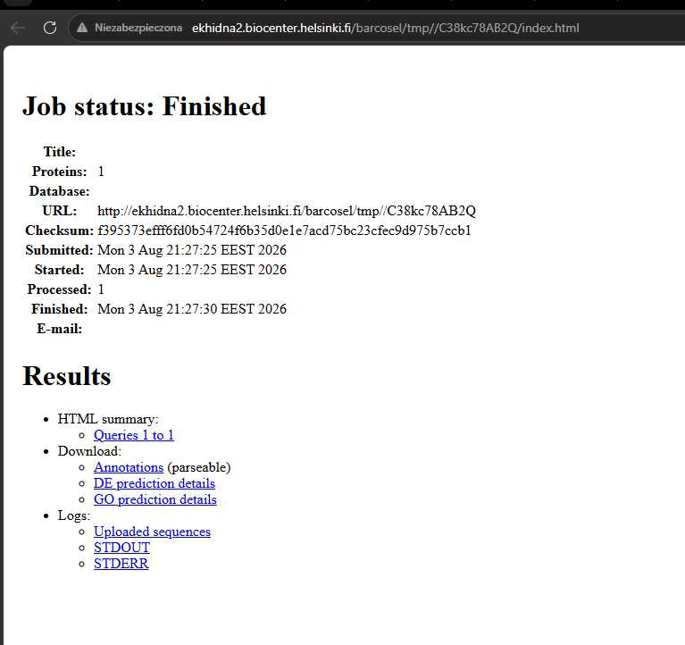
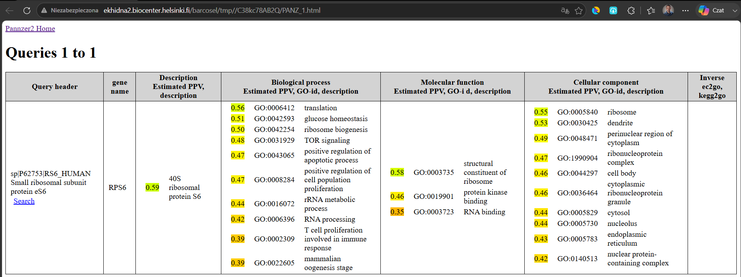
ekhidna2.biocenter.helsinki.fi/barcosel/tmp//C38kc78AB2Q/PANZ_1.html
2) RPS6 (P62753)
(wyniki z linku: C38kc78AB2Q/PANZ_1.html)
Biological process
- translation
- regulation of cell growth
- ribosome biogenesis
Molecular function
- structural constituent of ribosome
- RNA binding
Cellular component
- cytosolic small ribosomal subunit
- nucleolus
- ribosome

https://services.healthtech.dtu.dk/cgi-bin/webface2.cgi?jobid=6A70E3E9003136B70EB70806&wait=20

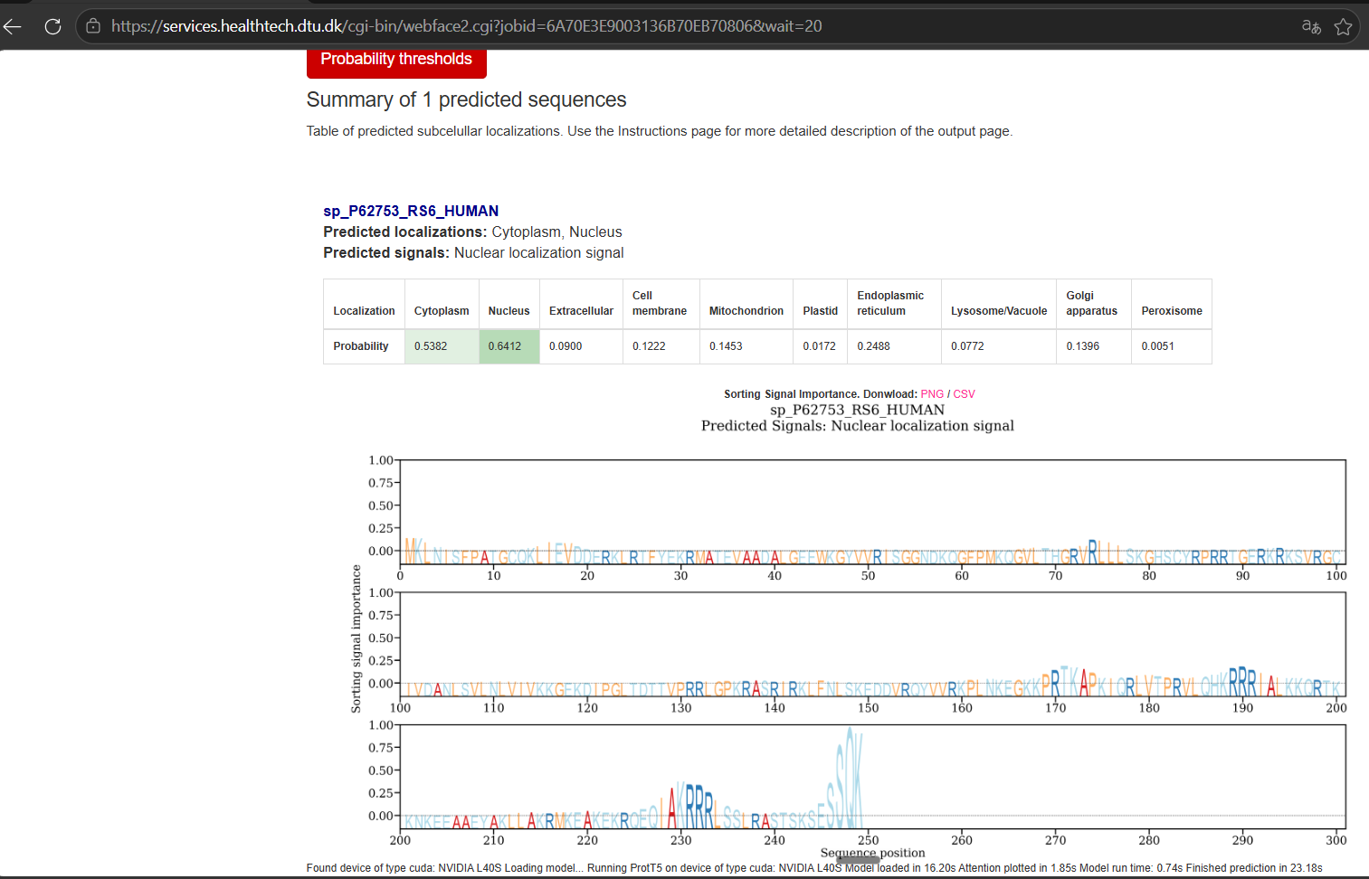

RPL3 (P39023)
>sp|P39023|RL3_HUMAN Large ribosomal subunit protein uL3 OS=Homo sapiens OX=9606 GN=RPL3 PE=1 SV=2
MSHRKFSAPRHGSLGFLPRKRSSRHRGKVKSFPKDDPSKPVHLTAFLGYKAGMTHIVREV
DRPGSKVNKKEVVEAVTIVETPPMVVVGIVGYVETPRGLRTFKTVFAEHISDECKRRFYK
NWHKSKKKAFTKYCKKWQDEDGKKQLEKDFSSMKKYCQVIRVIAHTQMRLLPLRQKKAHL
MEIQVNGGTVAEKLDWARERLEQQVPVNQVFGQDEMIDVIGVTKGKGYKGVTSRWHTKKL
PRKTHRGLRKVACIGAWHPARVAFSVARAGQKGYHHRTEINKKIYKIGQGYLIKDGKLIK
NNASTDYDLSDKSINPLGGFVHYGEVTNDFVMLKGCVVGTKKRVLTLRKSLLVQTKRRAL
EKIDLKFIDTTSKFGHGRFQTMEEKKAFMGPLKKDRIAKEEGA
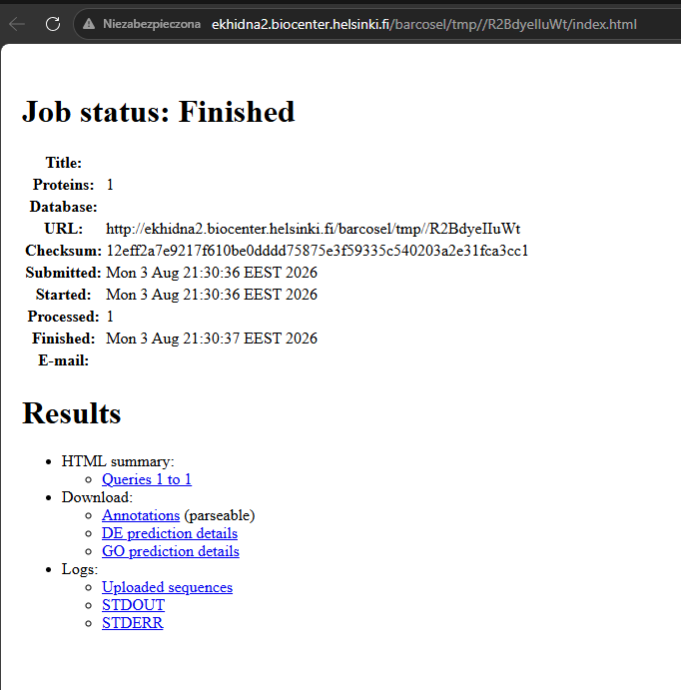
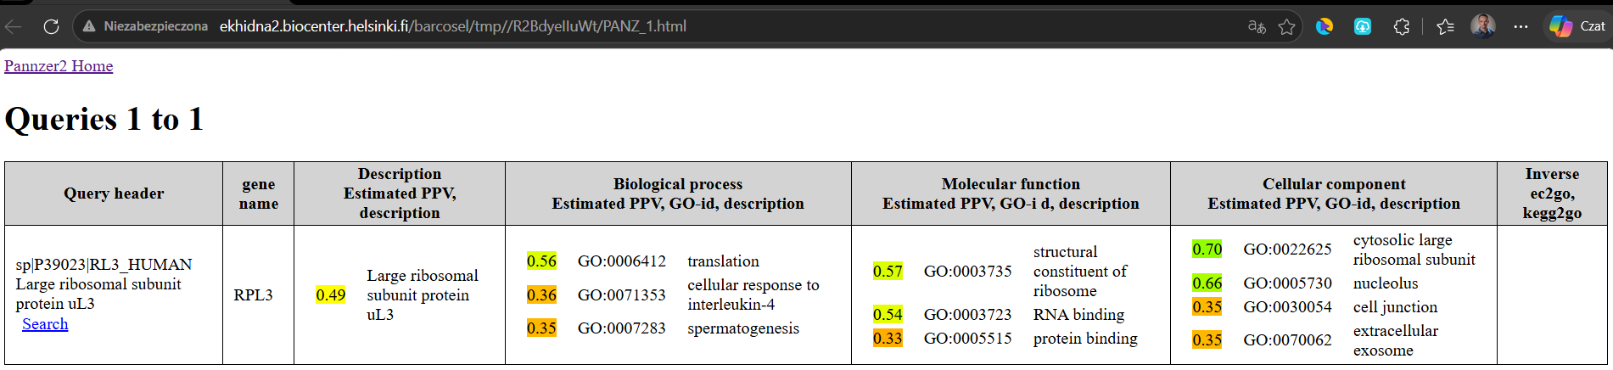
ekhidna2.biocenter.helsinki.fi/barcosel/tmp//R2BdyeIIuWt/PANZ_1.html
3) RPL3 (P39023)
(wyniki z linku: R2BdyeIIuWt/PANZ_1.html)
Biological process
- translation
- cellular response to interleukin-4
- spermatogenesis
Molecular function
- structural constituent of ribosome
- RNA binding
- protein binding
Cellular component
- cytosolic large ribosomal subunit
- nucleolus
- extracellular exosome

https://services.healthtech.dtu.dk/cgi-bin/webface2.cgi?jobid=6A70E4B1003138B9F23E175D&wait=20

